ASSIGNMENT -II

NAME: SOUMYADIP GHOSH

STREAM: CSE-A

ROLL NUMBER: 1951007

SUBJECT: OS LAB

Question 1: Write a program that accepts an integer num as command line argument. In your program create two processes. One process should report the num! (Factorial of num). The other process should report the summation of all factorials till num. [eg: if the argument is 5, one process calculates 5!=120, another process calculates 1!+2!+3!+4!+5!=153]. Each process should report its pid, ppid, and child id.

Code:

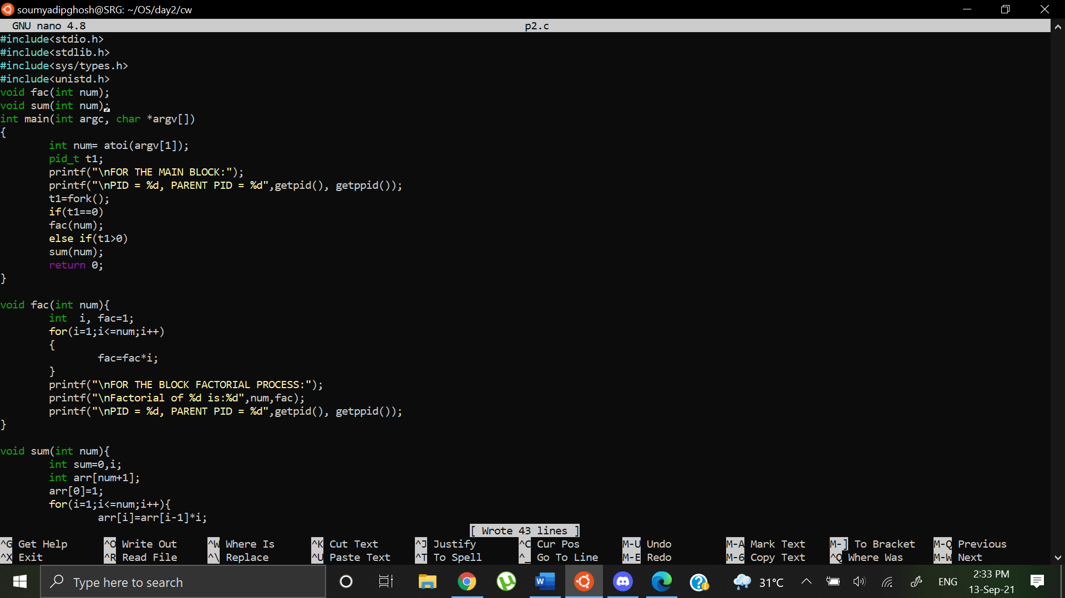

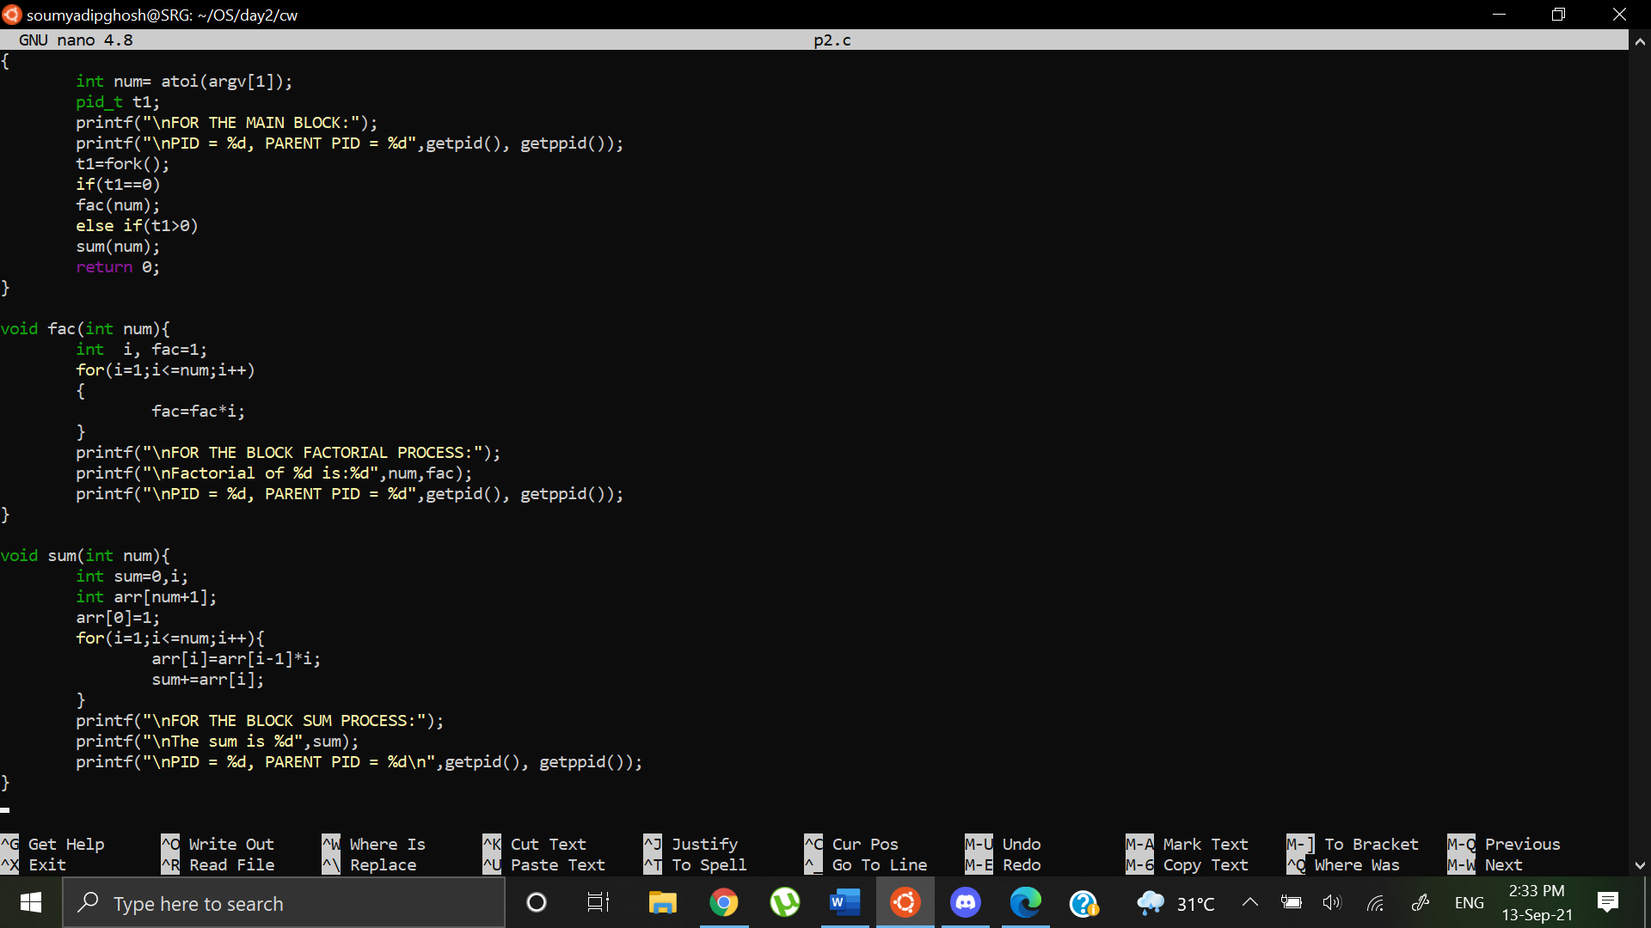

Output:

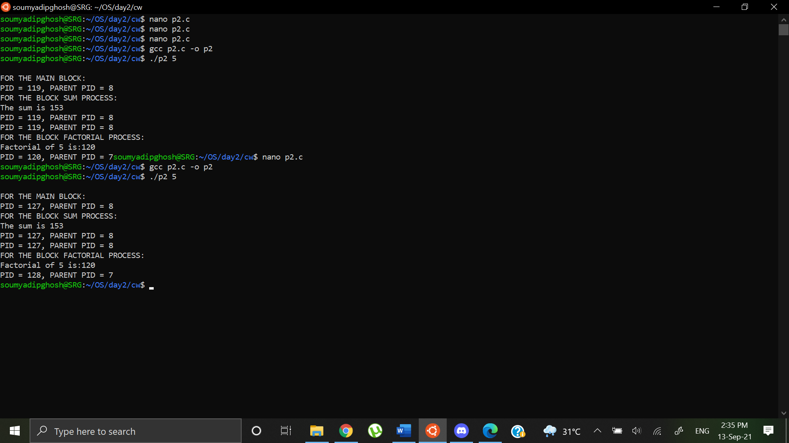

Question 2: Write a program to create exactly 3 processes. Each process should then display its own pid along with the pid of the other two processes and tis relation with the other two processes [grandparent/parent/child, parent/child-parent/child, parent/child/grandchild]. Take care so that you don’t have any unwanted orphan/zombie process(es). Each process should report its pid, ppid, and child id

Code:

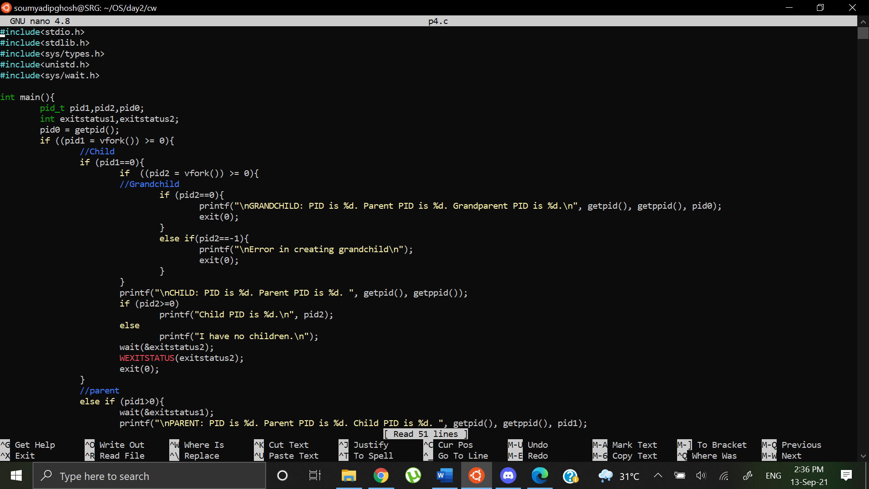

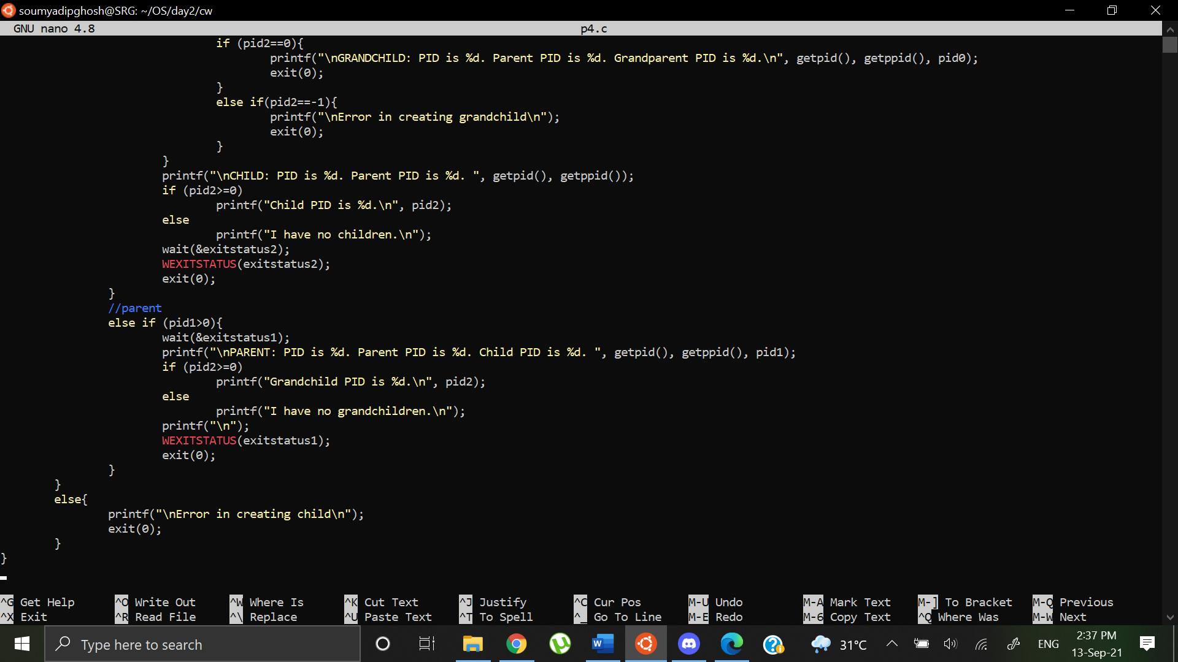

Output:

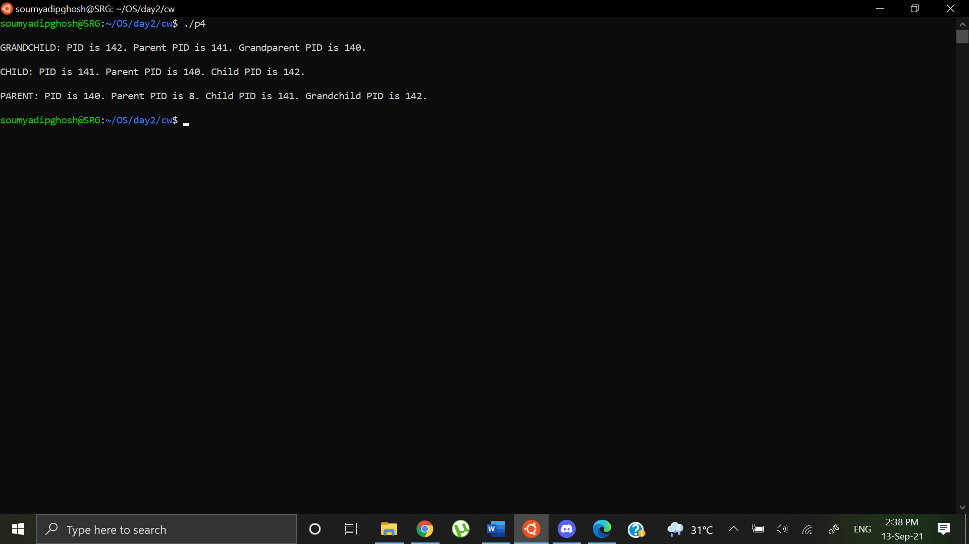

Question 3: Write a program that accepts two integers (low, high) as command line argument. Create two processes in your program. The first process should calculate the summation of all integers between (low, high) as sum_res. The second process should evaluate whether sum_res is prime or not. Each process should report its pid, ppid, and child id.

Code:

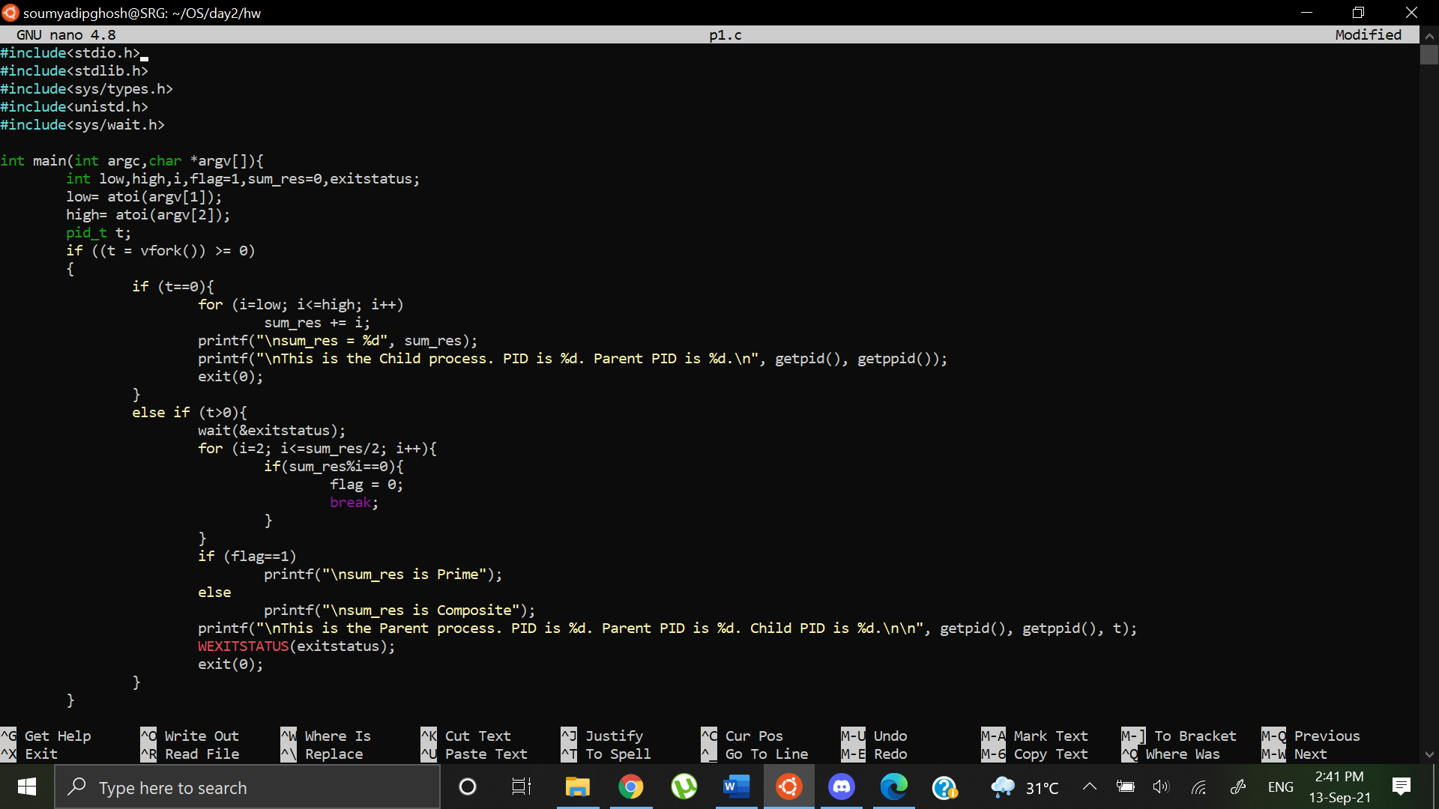

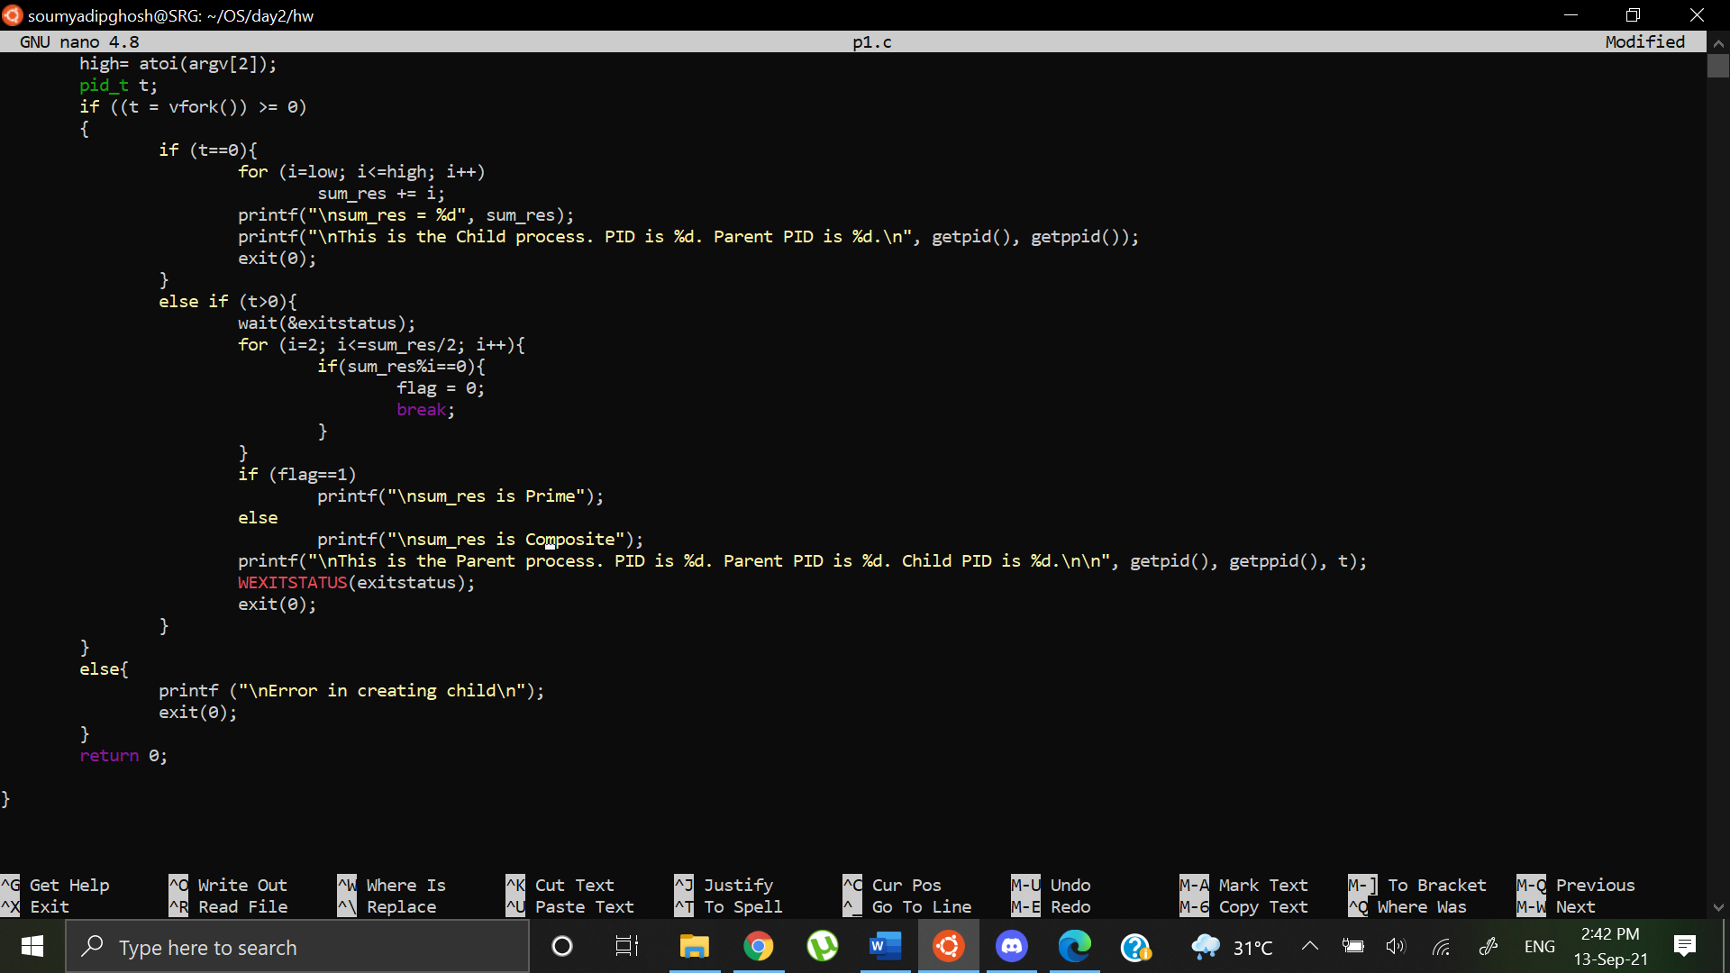

Output:

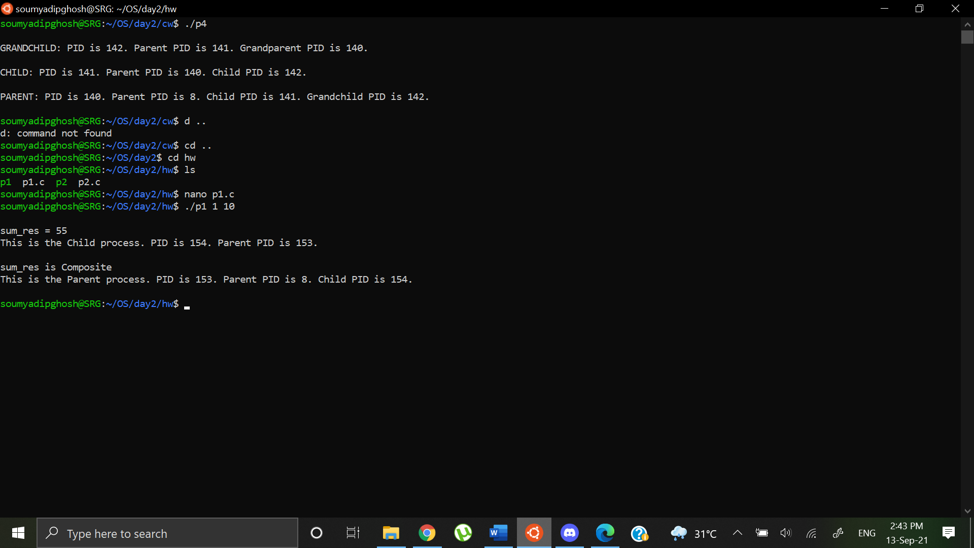

Question 4: Write a program to create exactly 3 processes. The program should accept two integers (min and max) as command line arguments. The first process should report the even and odd numbers within the range of min-max. The second process should report the prime and non-prime numbers within the range min-max. The third process should report the summation of even numbers and prime numbers within the range min-max

Code:

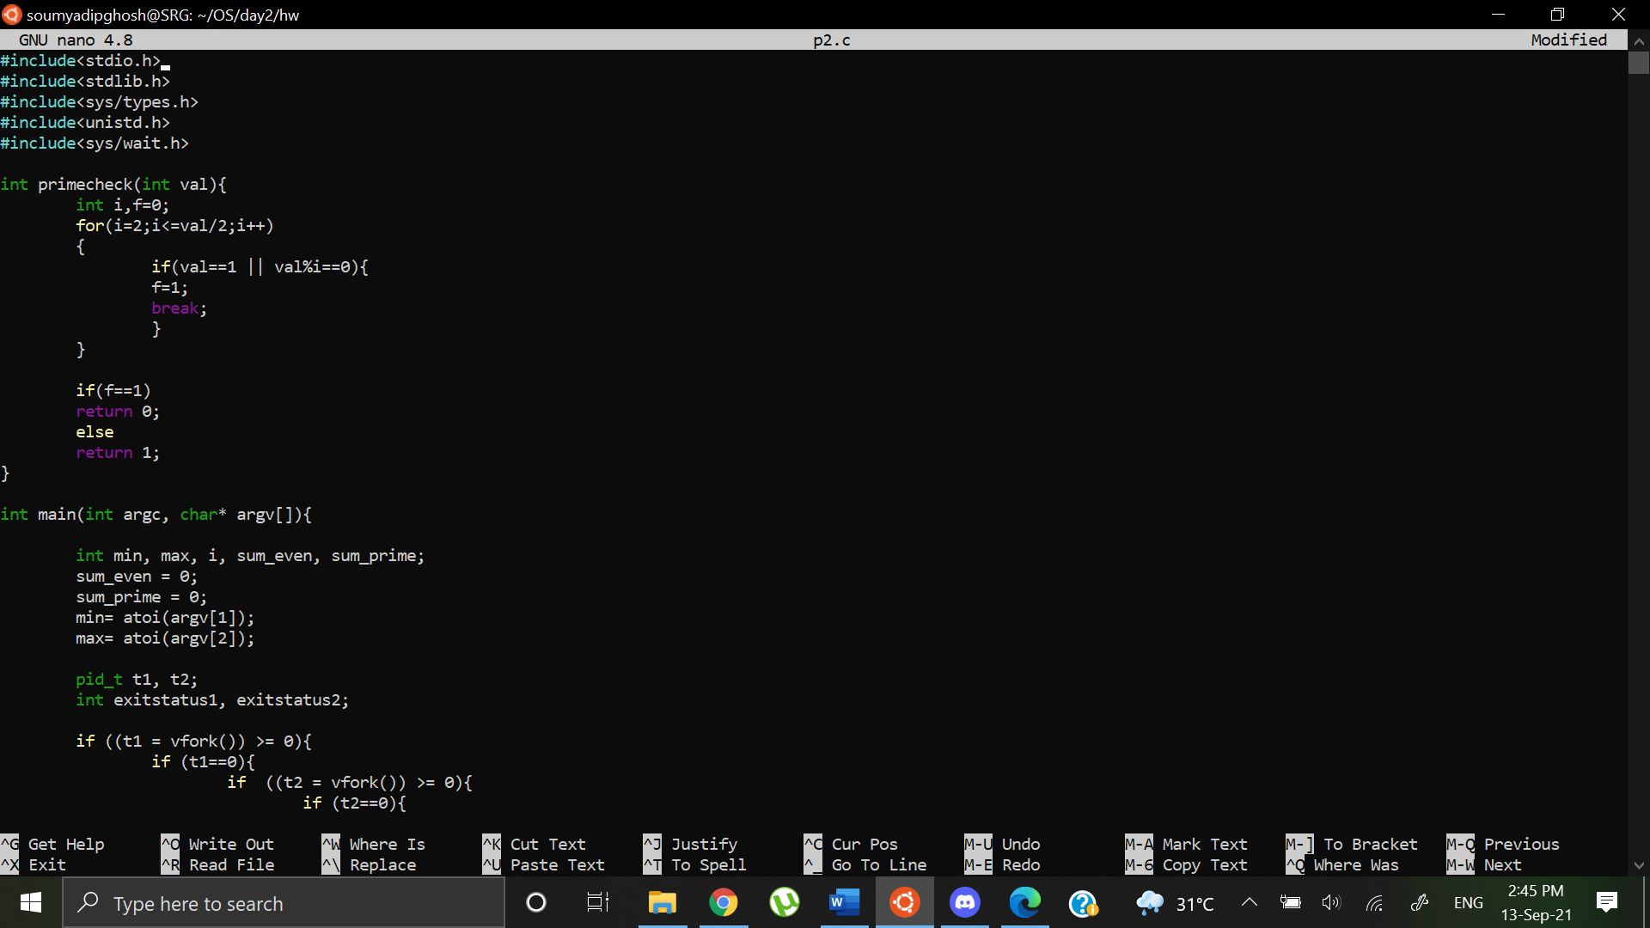

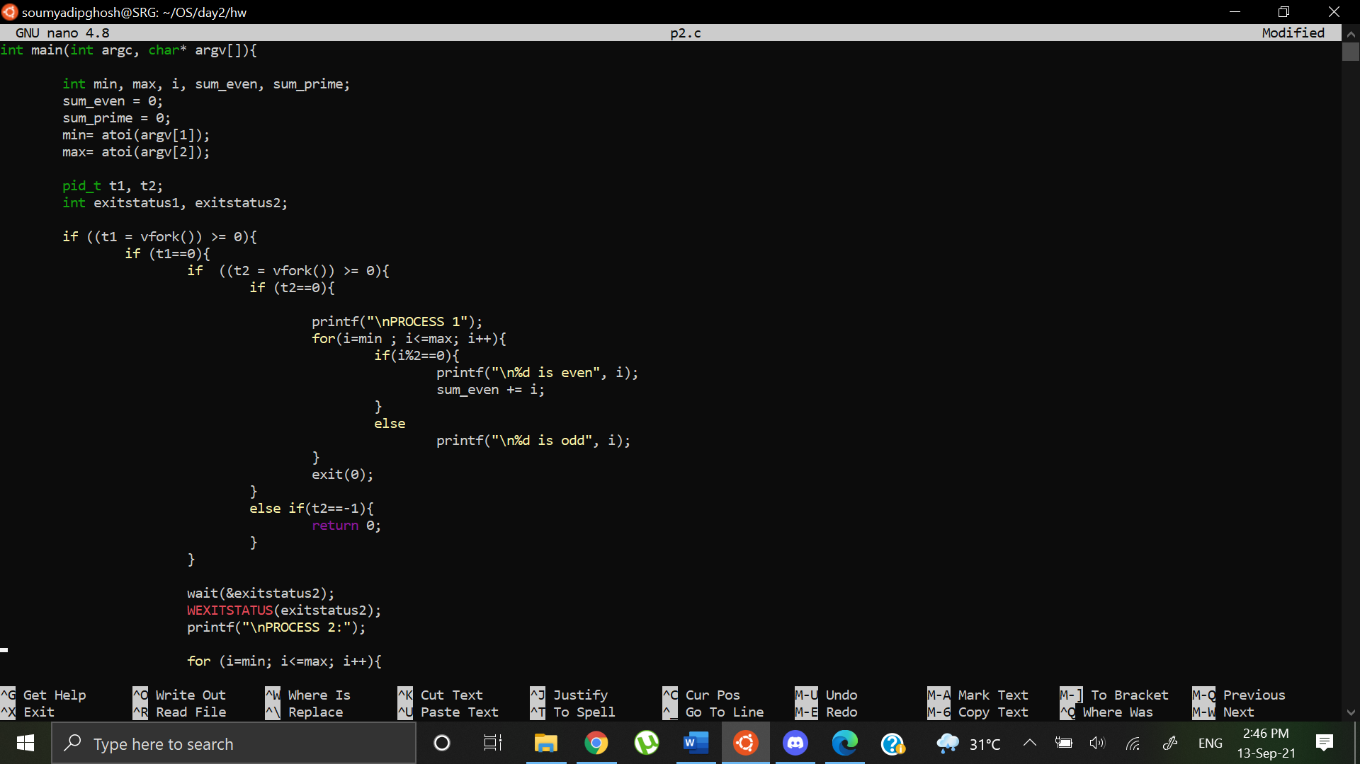

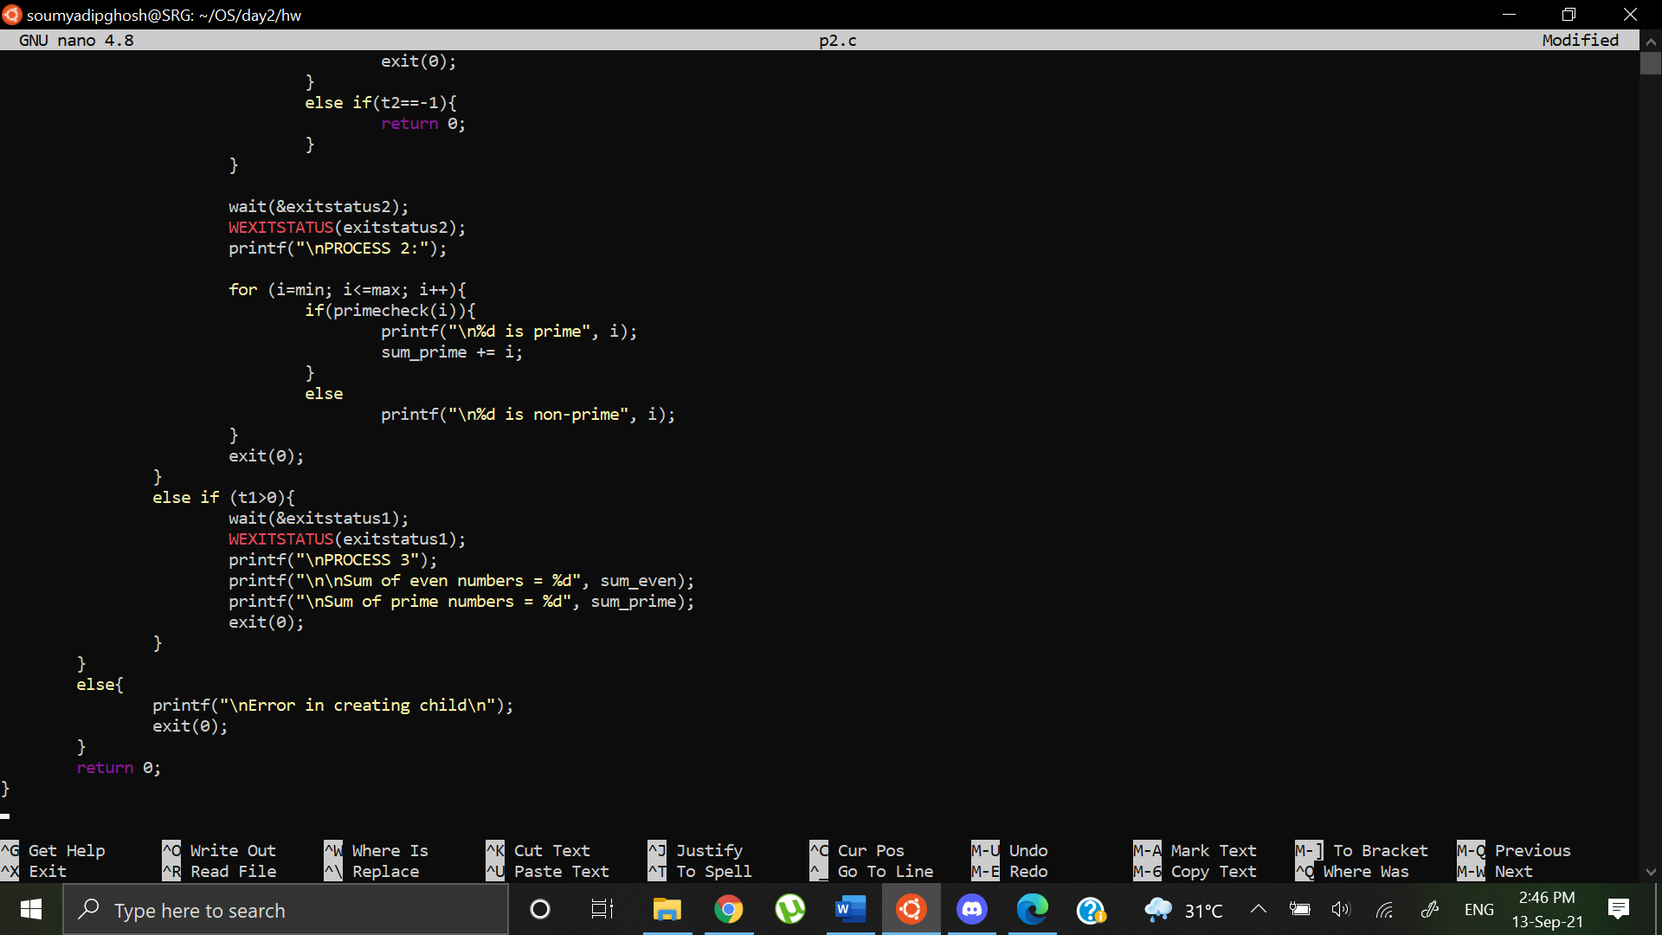

Output:

